**PROJECT TITLE**: LAPTOP REQUEST CATALOG ITEM

TEAM ID:NM2025TMID15936

TEAM SIZE:5

TEAM LEADER: SHALINI A

TEAM MEMBER: SARANYA S

TEAM MEMBER: RUBINI S

TEAM MEMBER: P.SHANMATHI

TEAM MEMBER: VINISHA V

**STEPS TO COMPLETE THE PROJECT:**

**Create Local Update Set**

1. Open service now.
2. Click on All  >> search for local update set.
3. Click on new and update the laptop request.

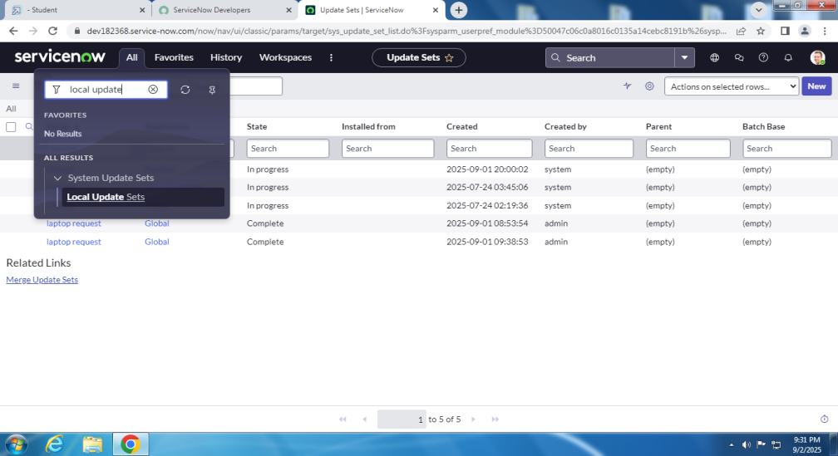

### Create Service Catalog Item

1. Click on All  >> service catalog(maintain items)

Fill the required details and create it.

1. add variables in it.

Create Catalog Ui Policies

### 

### In catalog ui policies,create a catalog item.

### Create Ui Action

### 1.all>>ui actions.

### 2.create a new ui actions with required details.

### Exporting Changes To Another Instances

### 1.all>>local update set>>laptop request>>need to change complete.

### 2.Export xml>>download the file.

### 

### Retrieving The Update Set

### Open another instance in another browers and import the xml file in it.

### Click on the commited update set.

### Test Catalog Item

### Atlast laptop request catalog item is created and it is tested.

### Final result is viewed in service catalog>>hardware>>laptop request.